Git Status-23rd Dec-2025
- Checked git status to add files worked until 23-Dec-2025
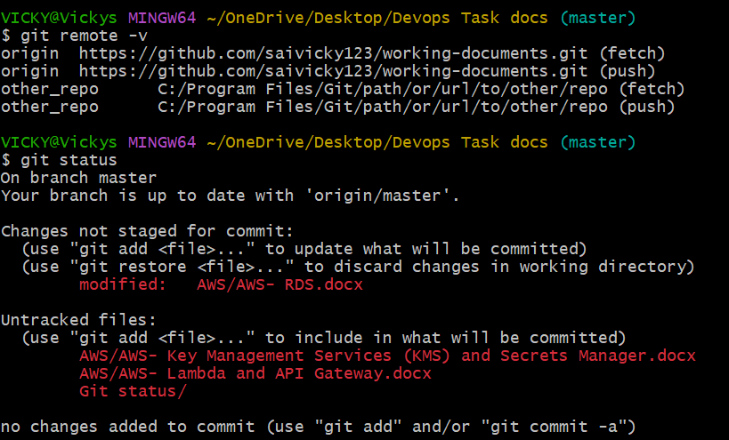
- Added files and sent to GitHub.
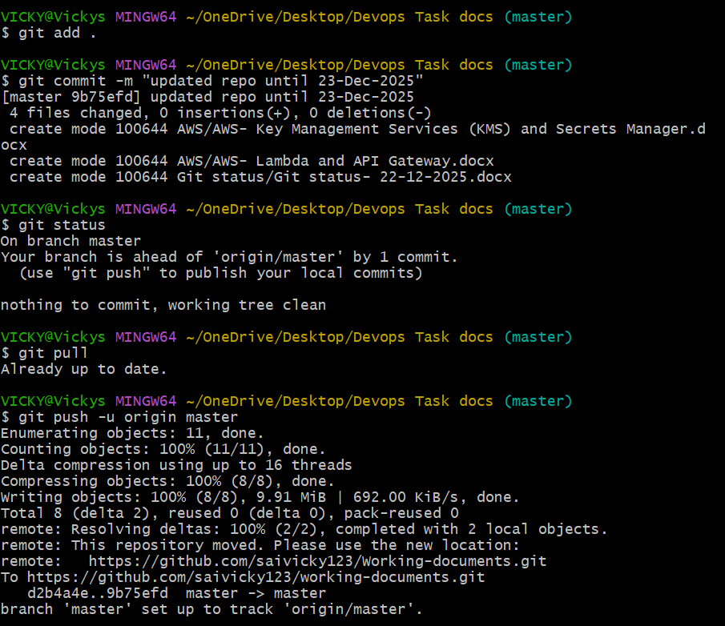

- Verified in GitHub All sent and stored.
